|  |
| --- |
| Java Collection |
|  |

A collection is an object that groups multiple elements into a single unit. It is helpful in storing, retrieving, and manipulating data.

Collections framework is a unified architecture to represent and manipulate collections in Java.

It is a collection of interfaces and classes which helps in storing and processing the data efficiently. Collection interface of the Collections framework has several child interfaces (Set, List, Queue, Deque) and classes(ArrayList, Vector, LinkedList, PriorityQueue, HashSet, LinkedHashSet, TreeSet) which are all part of the Collections Framework.

Collections Framework standardizes the way we store and access the data from collections and is a part of the **java.util package**.

**How Collections Framework is useful?**

This framework provides programmers with many pre-implemented data structures, thus saving their time. Collections implemented are efficient and have high performance.

These collections have many utility methods which makes it super easy for programmers to use them. They also come in handy while moving data back and forth between various methods or classes.

The Collections framework consists of three main interfaces at the top hierarchy – List, Set, Queue. These interfaces provide many general-purpose implementation classes like ArrayList, HashSet, HashMap, etc. These classes have been designed with high concurrent use in mind. They have thread-safe counterparts as well.

The diagram given below represents the hierarchy of the Java Collections framework.

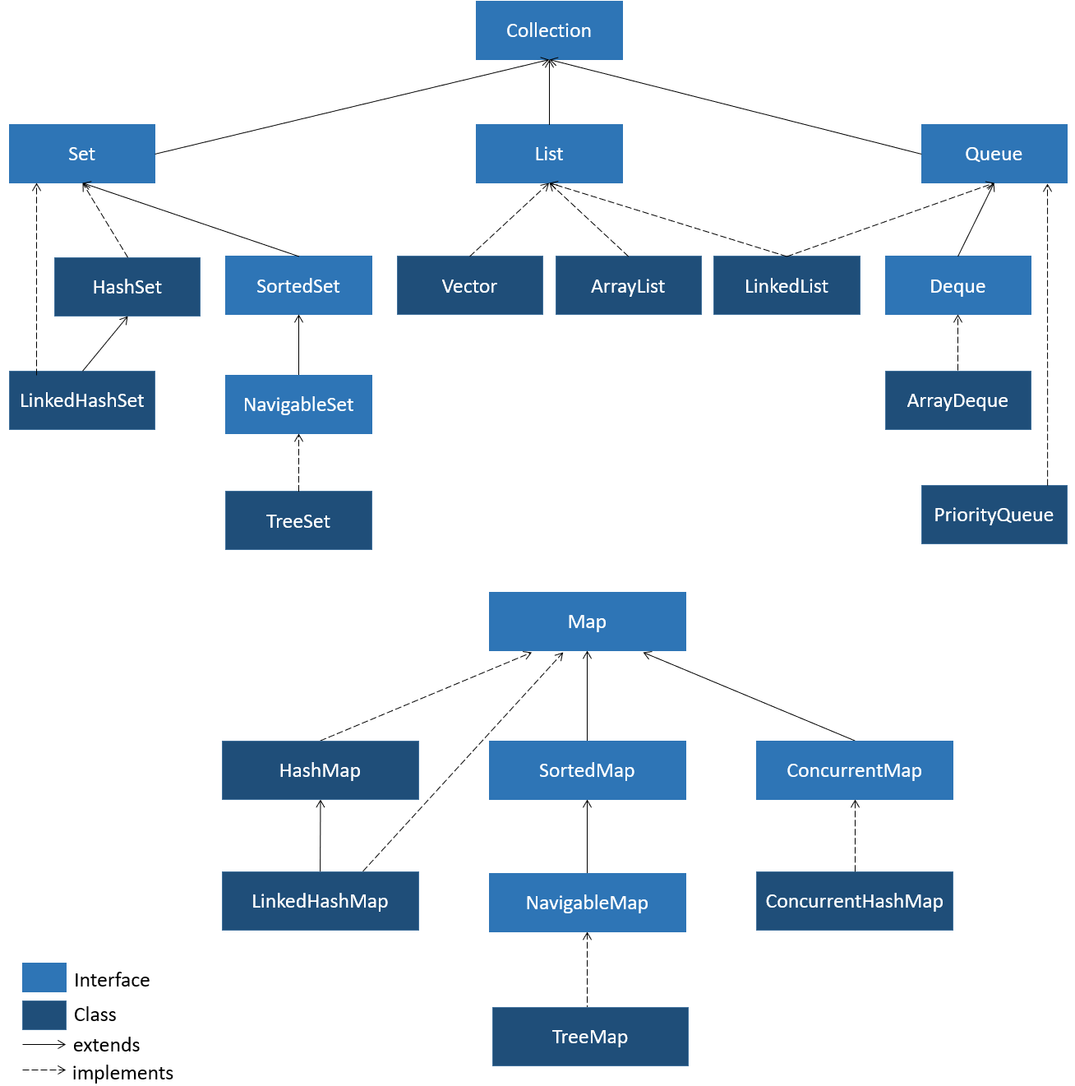

Let us look at various interfaces in detail.

The following describes the core collection interfaces, which form as the foundation of the Java Collections Framework:

* **Collection - the base of the collection hierarchy**
  + A collection represents a group of objects, which is also known as its elements.
  + Collections can be further classified based on their containing unique or duplicate elements, or on their ordered or unordered nature.
  + Collections do not have a direct implementations of its own, but has implementations for more specific sub-interfaces, such as Set, List, Queue, etc.
* **Set - a collection that can only contain unique elements**
* **List - an collection which is ordered and can have duplicate values**
  + **E**lements can be accessed by their index(position) and can be precisely controlled over where in the list, each element is inserted.
* **Queue and Deque (pronounced as "Deck") - collections used to hold multiple elements prior to processing**
  + Besides basic collection operations, a Queue and a Deque provides additional insertion, extraction, and inspection operations.
  + Queue
    - Queues typically but not necessarily, orders elements in a FIFO (first-in-first-out) manner. The exceptions being priority queues.
    - In a FIFO queue, all new elements are inserted at the tail of the queue. Other kinds of queues may use different placement rules.
  + Deque
    - Deques can be used both as FIFO (first-in-first-out) and LIFO (last-in-first-out).
    - In a Deque, all new elements can be inserted, retrieved and removed at both ends.
* **SortedSet - a set that maintains its elements in ascending order**
  + Several additional operations are provided to take advantage of the ordering

**What are the limitations of using an array?**

Let us consider the scenario of ordering food. Let us assume that the food items are collected in an array.

1. String[] orders = new String[size];

Assume that the size of the array is 4 and you have already placed 4 orders. Now, you want to add the fifth order, i.e., your favorite pizza.

Will you be able to add?

Since arrays have fixed size, ordering food items after a limit is not possible.

Also, once an order is processed or cancelled, it needs to be removed from the array. This requires extra array processing code for item removal:

1. public static void removeOrder(int orderIndex) {
2. for(int counter = orderIndex; counter < orders.length - 1; i++) {
3. orders[counter] = orders[counter + 1]; *// Shifting elements*
4. if(orders[counter + 1] == null) break; *// Null represents empty element*
5. else if(counter + 1 == orders.length-1) orders[counter + 1] = null;
6. }
7. currentIndex--;
8. }

 We need a collection which is dynamic in size and has utility methods for easy access and manipulation. Let us take a look at ArrayList.

ArrayList is a class implementing List interface. The base structure of this collection is Arrays. Using ArrayList issues of size limitations and extra processing code for item removal can be overcome. ArrayList is heterogeneous.

ArrayList placement in collection hierarchy is shown below-

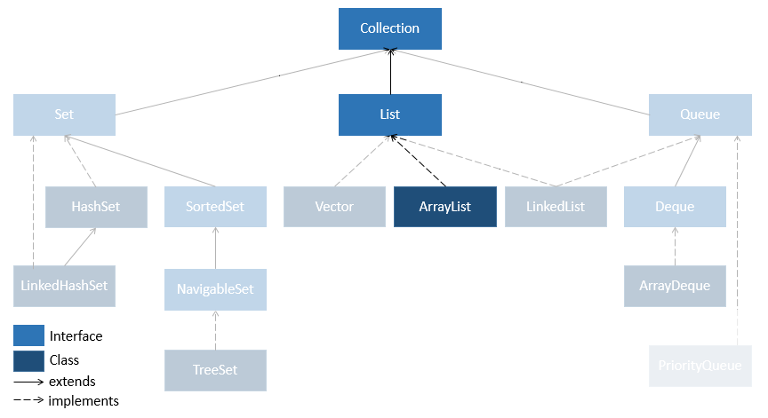

In ArrayList, the elements can be added or removed as and when required. Also, there is no need to maintain any index.

Let us create an ArrayList object called food.

1. ArrayList food = new ArrayList();

Let us now add elements to the ArrayList named food. The code below shows how to add food items to the ArrayList.

1. food.add("Noodles"); *// Adding the elements*
2. food.add("Burger");
3. food.add("Pasta");
4. food.add("Sandwich");

Displaying elements in a ArrayList -

1. System.out.println(food)

Displaying particular element of an ArrayList -

1. System.out.println(food.get(1)); *//1 is the index of element to be displayed*

Iterating over an ArrayList -

1. *//using traditional for loop*
2. for (int i = 0; i < food.size(); i++) {
3. System.out.println(food.get(i));
4. }
6. *//using enhanced for loop*
7. for (String temp: food) {
8. System.out.println(temp);
9. }

Heterogeneous ArrayList -

1. food.add("Noodles"); *// Adding the elements*
2. food.add("Burger");
3. food.add("Pasta");
4. food.add("Sandwich");
5. food.add(12);
6. food.add(true);
7. *//Above code will throw warning*
8. *//Enhanced for loop cannot be used to iterate over above list*

Does heterogeneous nature of ArrayList cause any problem. Let us see next.

**Issues with Raw Type List**

When you create an ArrayList without specifying any specific type then internally that list gets created by Object datatype. This means that elements added in the list are considered to be objects of Object class.

Let us take a look. Consider below list -

1. ArrayList numList = new ArrayList();
2. numList.add(2);
3. numList.add(3);
4. numList.add("four");

To iterate over an above list using enhanced for loop below code needs to be written -

1. for (Object element : numList) { *//cannot use String or Integer*
2. System.out.println(element);
3. }

This can become problematic. Consider the following code which prints the longest string present in an ArrayList-

1. public class Tester {
2. public static void main(String[] args) {
3. ArrayList nameList = new ArrayList();
4. nameList.add("Harrison");
5. nameList.add("Sirius");
6. nameList.add("James");
7. nameList.add("Lily");
8. nameList.add("Cho");
9. nameList.add("Hermione");
10. findLongestString(nameList);
11. }
13. public static void findLongestString(List list) {
14. String longest = "";
15. for (Object object : list) {
16. if(object.length() > longest.length()) *//Line1*
17. longest = object;
18. }
19. System.out.println("The string having the maximum length is "+ longest);
20. }
21. }

The code will give an error stating -"The method length() is undefined for the type Object".

In that case, how do we resolve it? How do we make sure that the List created stores only String data and does not convert it to the instance of an Object class?

This can be done using Generics. Let us see how to define and use generics.

**Generics**

Generics provide compile-time data type safety to code. They can be used in various places like Class, Interfaces, methods, arrays, etc. Typical syntax of Generic is to define datatype in angle brackets -

1. ArrayList<String> nameList = new ArrayList<String>();

**Now if we try to add any datatype object other than String, code will throw compilation error.**

**Resolving issue with previous code**

The problem with the previous code can be resolved when used in the following manner-

1. public class Tester {
2. public static void main(String[] args) {
3. ArrayList<String> nameList = new ArrayList<String>();*//Line1*
4. nameList.add("Harrison");
5. nameList.add("Sirius");
6. nameList.add("James");
7. nameList.add("Lily");
8. nameList.add("Cho");
9. nameList.add("Hermione");
10. findLongestString(nameList);
11. }
13. public static void findLongestString(List<String> list) {
14. String longest = "";
15. for (String object : list) {
16. if(object.length() > longest.length())
17. longest = object;
18. }
19. System.out.println("The string having the maximum length is "+ longest);
20. }
21. }

This code will give up an output, "The string having the maximum length is Harrison."

Also, observe the changes done for the above code. During the declaration of nameList, we are also adding the String class to it using the <> operator. This is Generics.

Generics help in creating classes, interfaces, and/or methods in which the type of object on which they operate is mentioned as a parameter.

By the use of Generics in our above code, we make sure that,

* Objects of String class do not get converted to the Object class.
* The **nameList**will accept data of type String only.

Note: The Collection Interface uses Generics so as to eliminate the need to create separate classes and interfaces for each data type.

But can Generics be used only with the Collection framework? Or can we make use of Generics in anycode?

Now let us see the usage of Generics for a user-defined method and a user-defined class.

**Generic Method:**

1. class GenericMethod {
2. public static <E> void displayDetails (E[] inputArray) {
3. for (E e : inputArray) {
4. System.out.print(e+" ");
5. }
6. System.out.println();
7. }
8. }

The **displayDetails**method shown above takes an array as the parameter, and prints all the elements of the array. Since we have added Generics in this method, it will accept arrays of all the datatypes. The character**E** used in the method is called a Type Parameter. It replaces itself with the data type of the array that is passed during the execution. For example, if we use an Integer array, then **E** replaces itself with Integer. We can invoke the function as shown below-

1. Integer[] intArray = {1,4,5,2,3};
2. GenericMethod.displayDetails(intArray);
3. *//The output will be: 1 4 5 2 3*
4. String[] sarr = {"One","Two","Three"}
5. GenericMethod.displayDetails(sarr);
6. *//The output will be: One Two Three*

**Using Generic with a Class**

Consider code below -

1. public class EqualityTester<T> {
2. T value1; *//declaring instance variable of T type*
3. T value2;
4. public EqualityTester(T value1, T value2) {
5. this.value1=value1;
6. this.value2=value2;
7. }
8. public boolean checkEquals() {
9. return value1.equals(value2);
10. }
11. }

In the above class,  we see that there is Type Parameter **E** attached to the class. The same Type Parameter is used to declare the datatype of **value1, value 2**attributes. This has to be declared during the object creation phase. The data type declared during the object creation will be replacing the Type Parameter at all places in the class.

Note: By convention, the type parameter is denoted by a single capital letter and is commonly one among **E** (element), **T** (type), **K** (key), **N** (number), or **V** (value).

To use the class, creation of the object and method call will look like -

1. EqualityTester<Integer> tester1 = new EqualityTester<Integer>(10, 20);
2. System.out.println(tester1.checkEquals()); *//prints false*
3. EqualityTester<String> tester2 = new EqualityTester<String>("Ten", "Twenty");
4. System.out.println(tester2.checkEquals()); *//prints false*

Generics can be used with user-defined classes as well. Take a look at code below -

1. *//creating Employee class*
2. class Employee{
3. private int empId;
4. public Employee(int empId){
5. this.empId = empId;
6. }
7. }
8. *//Adding employees to a list having Employee used in Generic*
9. ArrayList<Employee> elist = new ArrayList<Employee>();
10. elist.add(new Employee(101));
11. elist.add(new Employee(102));
12. elist.add(new Employee(103));

Generics can have multiple data types defined as well.

1. public class ArraysLengthTester<T1,T2> { *//T1,T2 are two data types*

4. *//method takes two array type parameters of type T1,T2*
5. public String lengthTester(T1[] arr1,T2[] arr2) {
6. return (arr1.length==arr2.length?"Equal":"Not Equal");
7. }
8. public static void main(String[] args) {
9. String[] sarr = {"A","B","C"};
10. Integer[] numarr1 = {1,2,3,4};
11. Integer[] numarr2 = {4,5,6,7};
13. ArraysLengthTester<String,Integer> tester1 = new
14. ArraysLengthTester<String,Integer>();
15. System.out.println(tester1.lengthTester(sarr, numarr1));
17. ArraysLengthTester<Integer,Integer> tester2 = new
18. ArraysLengthTester<Integer,Integer>();
19. System.out.println(tester2.lengthTester(numarr1, numarr2));
21. }
22. }

Hence, we can see Generics provide robustness of data types in the collection.

Now let us take a look at various methods available in the ArrayList class.

The table below shows a few methods of ArrayList.

| ArrayList methods | |
| --- | --- |
| Method | ****Description**** |
| void add(int index, Object element) | inserts the specified element to the specified position in the ArrayList |
| boolean add(Object o) | appends the specified object to the end of the ArrayList |
| boolean addAll(Collection c) | appends all the elements of the specified collection to the end of the ArrayList |
| boolean addAll(int index, Collection c) | inserts all the elements of the specified collection into the ArrayList, starting at the specified position |
| Iterator iterator() | returns an iterator over the elements in the set |
| void clear() | removes every element of the ArrayList |
| boolean contains(Object element) | returns True if the specified element is present in the ArrayList |
| Object get(int index) | returns the element present in the specified position |
| int indexOf(Object element) | returns the first occurrence of the specified element |
| boolean isEmpty() | returns True if the ArrayList has no elements |
| int lastIndexOf(Object element) | returns the last occurrence of the specified element |
| Object remove(int index) | removes the element present at the specified index of the ArrayList |
| Object set(int index, Object element) | replaces the element at the specified index in the ArrayList with the specified element |
| int size() | returns the number of elements in the ArrayList |
| void sort(Comparator c) | sorts the ArrayList according to the order given by the Comparator |

You can read more about ArrayList methods in the [Oracle docs](https://docs.oracle.com/en/java/javase/11/docs/api/java.base/java/util/ArrayList.html).

Let us see the implementation of various methods of ArrayList class.

The code below shows how to add food items to the ArrayList.

1. food.add("Noodles"); *// Adding the elements*
2. food.add("Burger");
3. food.add("Pasta");
4. food.add("Sandwich");

The code below shows how to modify the food item present in a specified index of the ArrayList.

1. food.set(1, "Pizza"); *// Modifying the element at a specified index*

The code below checks whether the food item is present in the ArrayList or not.

1. food.contains(2, "Pasta"); *// Checking whether the element is present or not*

Let us remove pasta from the ArrayList. Pasta is present in the second index of the ArrayList. The position of the element to be removed should be specified in the method as shown below.

1. food.remove(2); *// Removing the element from the second index*

sort() of the ArrayList class overrides the sort method of the List interface, used for sorting the elements based on the order given by Comparator. sort() will be discussed in detail later.

We have already seen the use of loops to iterate over an ArrayList. The collection framework provides an Iterator that provides a general-purpose iterating mechanism for looping over collections like List, Set, etc.

**Iterator**

Collections like ArrayList have a method called **iterator()**. This method returns an Iterator type object which is used iterator over elements of the list. It is an implementation of the Iterator interface's iterate() method.**hasNext()** and **next()** are the important methods that are declared by the Iterator interface.

Let us see how to get an iterator object

1. List<String> nameList = new ArrayList<String>();
2. nameList.add("Harrison");
3. nameList.add("Sirius");
4. nameList.add("James");
5. nameList.add("Lily");
7. *//getting iterator object*
8. Iterator<String> itr = nameList.iterator();

Below are method details of Iterator interface.

| **ArrayListIterator methods** | |
| --- | --- |
| **Method** | **Description** |
| **boolean hasNext()** | **returns true if the iteration has more elements** |
| **E next()** | **returns the next element in the iteration** |
| **void remove()** | **removes the current element in the iterator** |

**ListIterator**

List interface exclusively provides the ListIterator which is a sub-interface of Iterator. It allows traversing a list in both forward and reverse directions. ListIterator, apart from above methods also has the hasPrevious() and previous() methods.

Below is the code to get ListIterator object.

1. ListIterator<String> listIterator = nameList.listIterator();

| **ArrayListIterator methods** | |
| --- | --- |
| **Method** | **Description** |
| **boolean hasPrevious()** | **returns true if this list iterator has more elements when traversing the list in the reverse direction** |
| **E previous()** | **returns the previous element in the list and moves the cursor position backwards** |

Let us see how to use above methods to iterate over ArrayList.

**Using iterator()**

Let us take a look at code to get iterator object on ArrayList and using its methods to iterate

1. List<String> nameList = new ArrayList<String>();
2. nameList.add("Harrison");
3. nameList.add("Sirius");
4. nameList.add("James");
6. *//iterating using iterator()*
7. *//Getting Iterator object*
8. Iterator<String> iterator = nameList.iterator();
9. while(iterator.hasNext()) {
10. System.out.println(iterator.next());
11. }

**Using listIterator()**

Let us take a look at code to get ListIterator object on ArrayList and using its methods to iterate in both forward and reverse direction.

1. List<String> nameList = new ArrayList<String>();
2. nameList.add("Harrison");
3. nameList.add("Sirius");
4. nameList.add("James");

7. *//iterating using listIterator()*
8. *//Getting ListIterator object*
9. ListIterator<String> literator = nameList.listIterator();
11. *//iterating in forward direction*
12. while(literator.hasNext()) {
13. System.out.println(literator.next());
14. }
15. *//iterating in reverse direction*
16. while(literator.hasPrevious()) {
17. System.out.println(literator.previous());
18. }

remove() method is used to remove elements from a collection while iterating over it. Removing elements in this way can cause errors if collection is getting modified simultaneously by other methods.

 Java Collections framework also provides LinkedList class which removes the need of creating your own class for implementing a linked list.

LinkedList class implements the List interface as shown below.

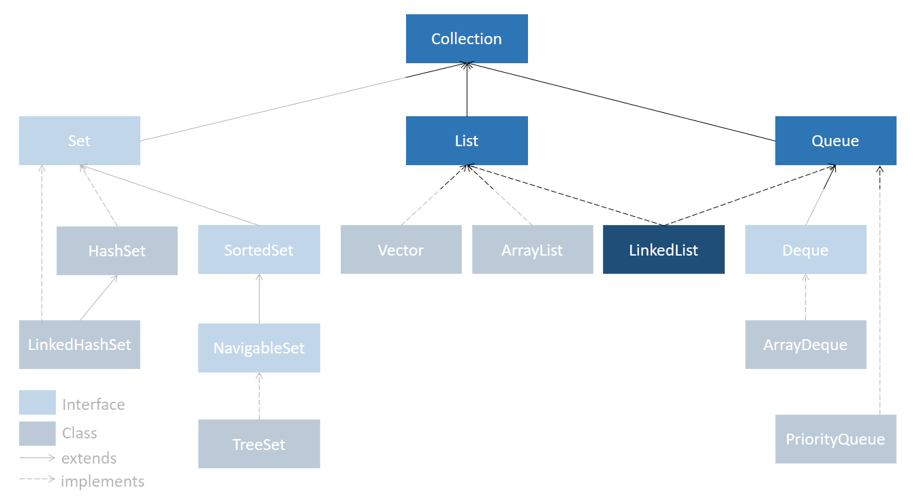

Let us take a look at various methods of linked list class.

A linked list can be created as shown below.

1. LinkedList<String> myList = new LinkedList<String>();

After a linked list is created, you can use methods for operations on linked list.

The table below shows some methods of LinkedList.

| **LinkedList methods** | |
| --- | --- |
| **Method** | **Description** |
| void add(int index, E element) | inserts the specified element at the specified index |
| boolean add(E element) | inserts the specified element at the end of the list |
| void clear() | removes all the elements from the list |
| boolean contains(Object o) | returns true if the list contains the specified object |
| E get(int index) | returns the element at the specified index |
| int indexOf(Object o) | returns the index of the first occurrence of the specified object |
| boolean remove(Object o) | removes the first occurrence of the specified object |
| E set(int index, E element) | replaces the element at the specified index |
| Object [] toArray() | returns an array containing all the elements in the list |
| int size() | returns the number of elements in the list |

Comparable Interface is from java.lang package which has only one method compareTo(Object). The comparable interface helps in ordering the objects of a class that implements it. Because of this ordering, objects can be sorted. Sorting can be done on one attribute at a time.

**Syntax:**

1. public Comparable<T>
2. *//T is the type of object which need to be compared*

Now let us learn more about the compareTo().

# **compareTo(<T> object) :**

Syntax:

1. public int compareTo(<T> object)

This method is used to compare the current object with the object passed in the argument. This helps in deciding the ordering of objects called Natural Ordering.

This method returns an integer and if it returns -

* zero, it means the current object is equal to the passed object
* a positive integer, it means the current object is greater than the passed object
* a negative integer means the current object is lesser than the passed object

String class and Wrapper class implements Comparable Interface by default. But to compare and sort user-defined objects we need to implement a Comparable interface.

Let us look at an example:

The code given below, sort the Employee objects in Tester class based on employeeId attribute of the class. When an employee joins the company he/she is assigned an Employee Id in increasing order. Employees having smaller employeeId have higher experience in the company as compared to employees having larger employeeId.

Consider below Employee class implementing Comparable interface for comparing objects.

1. class Employee implements Comparable<Employee> {
2. Integer employeeId;
3. String name;
4. Double salary;
5. Employee(Integer employeeId, String name, Double salary) {
6. this.employeeId = employeeId;
7. this.name = name;
8. this.salary = salary;
9. }
10. }

Let us look at how to override compareTo() method

1. @Override
2. public int compareTo(Employee employee) {
3. *//compareTo() receives another Employee object as an argument to compare with the current Employee object.*
4. if (employeeId == employee.employeeId)
5. return 0;
6. else if (employeeId > employee.employeeId) {
7. return 1;}
8. else
9. return -1;
10. }
11. }
12. *//It compares employeeId of both the objects and returns the result as an integer.*

The return value of compareTo() decides the ordering of objects.

The collection/array of objects which implement Comparable Interface can be sorted using Collections.sort() or Arrays.sort()

Let us create few Employee objects, add them to a list and try to sort them.

1. Employee employee1 = new Employee(341, "John", 35000.00);
2. Employee employee2 = new Employee(103, "Sam", 30000.00);
3. Employee employee3 = new Employee(221, "Albert", 40000.00);
5. List<Employee> employeeList = new ArrayList<Employee>();
6. employeeList.add(employee1);
7. employeeList.add(employee2);
8. employeeList.add(employee3);
9. *// Below sort() method uses compareTo() method to sort the given objects*
10. Collections.sort(employeeList);
11. *// Sorted objects are displayed below.*
12. for (Employee e : employeeList) {
13. System.out.println(e.employeeId + " " + e.name + " " + e.salary);
14. }

If you observe the output you will see that Employee objects are now sorted based on employeeId.

1. 103 Sam 30000.0
2. 221 Albert 40000.0
3. 341 John 35000.0

You will further explore this concept in tryouts.

Chill n' Grill is a new food stall chain in the city that allows its customers to order food items online. Each order can have more than one item. The code for the same is given below. Your task is to display each order with all the items.

**Sample Output:**

Displaying order details  
Order Id:101  
Items:  
FriedRice  
Pasta  
Thortilla  
-----------------------  
Order Id:102  
Items:  
Pizza  
Pasta  
-----------------------  
Order Id:103  
Items:  
Burger  
Sandwich  
Pizza  
-----------------------

Note: Check the project using SonarLint to maintain the coding standards. Ignore the violations which occur due to "System.out" statements.

Let us assume that the following food items are ordered. Observe that there are repeated entries of few food items.



Now, the task is to find out the unique entries in the list. Instead of manually finding out the duplicate entries, it would be better if there is a collection which can automatically remove duplicate elements.

This can be done by using a collection called Set.



Set represents an unordered collection with unique elements. It is present in the java.util package. Just like List, Set also has several implementations.

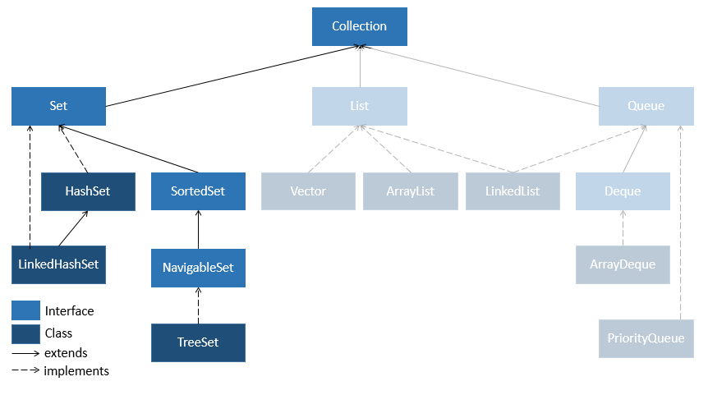

**HashSet**

HashSet is a concrete class which implements Set interface. To store elements HashSet uses hashing mechanism.Hashing involves determining a unique value by using a key. This unique value is called as hashcode. Then this hashcode is used for indexing the data associated with the key.

HashSet can contains only unique elements. When iterated elements in a HashSet are returned in a random order. We can store Null values in a set.

**LinkedHashSet**

In this type of Set, elements are returned in the order of their insertion.

**TreeSet**

It uses tree-based data structure for storing elements. Unique elements are arranged in their natural ordering inside the set. It throws a runtime exception if heterogeneous objects are inserted. It depends on the compareTo() method for ordering as well as for detecting duplicates.

Let us see how to create object of a HashSet

1. HashSet<String> food = new HashSet<String>(); *// Creating HashSet*

Adding elements to a HashSet-

1. *// Create HashSet*
2. food.add("Pasta"); *// Add elements to the hash set*
3. food.add("Noodles");
4. food.add("Sandwich");
5. food.add("Pasta");
6. food.add("Burger");
7. food.add("Noodles");

Looping over a HashSet -

1. *//printing all users*
2. for (String tempFood : food) {
3. System.out.println(tempFood);
4. }

Iterating over a set -

Set interface also has iterator() method available which can called on HashSet Object to return an Iterator object.

1. *//creating Iterator object using iterator() method*
2. Iterator<String> iterator = food.iterator();
3. *//using hasNext() method to find if next element is present*
4. while(iterator.hasNext()) {
5. *//using next() method to get the next element*
6. System.out.println(iterator.next());
7. }

Converting list to a set-

1. *// Creating HashSet*
2. HashSet<String> food = new HashSet<String>();
3. *//Creating List*
4. List<String> foodList = new ArrayList<String>();
5. foodList.add("Pasta");
6. foodList.add("Noodles");
7. foodList.add("Sandwich");
9. *// Add elements to the hashset from list*
10. food.addAll(foodList);

You can read more about [HashSet class here](https://docs.oracle.com/en/java/javase/11/docs/api/java.base/java/util/HashSet.html).

Next let us see what happens if we add user defined objects in a Set.

**Adding user defined objects in a Set**

Set is a collection that automatically **removes duplicates** when added. Let us see what happens if the objects of user-defined are added to a Set.

Consider a class User having username, password and email as properties. In context of a business scenario if two users have the same username then they are equal or same.

1. class User {
2. String username;
3. String password;
4. String email;
5. }

Consider below list of User objects-

1. *// creating a list of users*
2. List<User> userList = new ArrayList<User>();
3. userList.add(new User("Max", "fgc123", "max@infy.com"));
4. userList.add(new User("Mike", "hdgsh@", "imike@infy.com"));
5. userList.add(new User("John", "ucantseeme", "jojo@infy.com"));
6. userList.add(new User("Moby", "fgc123", "iammoby@infy.com"));
7. userList.add(new User("Moby", "fgc123", "iammoby@infy.com"));

 Converting this list to a Set as below –

1. *// creating user set from list*
2. Set<User> userSet = new LinkedHashSet<User>();
3. userSet.addAll(userList);
5. *//printing all users*
6. for (User user : userSet) {
7. System.out.println(user);
8. }

While observing the output we will see that **two ‘Moby’ objects** are appearing in the output. Ideally as they are added in a Set, duplicate should have been removed. But this did not happen.

1. Max : max@infy.com
2. Mike : imike@infy.com
3. John : jojo@infy.com
4. Moby : iammoby@infy.com
5. Moby : iammoby@infy.com

**Why duplicate objects were not removed from the Set?**

The answer lies in the implementation of **equals()**and **hashCode()** method of Object class. By default **equals()** method compares object reference to check if two objects are equal or not. Here as two independent objects get added, they are considered to be unequal and hence considered as different by set, so they are not removed.

**Overcoming the equality problem**

To solve this problem we need to override equals() method in User class. Here, we will consider two users to be same if they have same username.

1. @Override
2. public boolean equals(Object user) {
3. User tempuser = null;
4. boolean flag = false;
5. if (user instanceof User) { *//instanceof tests if passed object is of User class or not*
6. tempuser = (User) user;
7. flag=this.username.equals(tempuser.username);
8. }
9. return flag;
10. }

Since we have overridden equals(), now if we try to print the Set elements once again to check whether the duplicate ‘Moby’ has been removed, we find that duplicate **‘Moby’ object still exists** in the Set.

This is because we have overridden only equals() and**did not override hashCode()**. It is necessary to override both equals() and hashCode() methods due to the general contract defined for these methods on Object class. Also, HashSet class uses the value returned by hashCode() method to determine where and how the object will be stored.

Let us override hashCode() method.

1. @Override
2. public int hashCode() {
3. return username.length();
4. }

Now, if we try printing the Set elements we will find duplicate ‘Moby’ object is gone.

Tree House is a book store. The number of books available in the store is huge and it becomes very difficult to locate the books.

The bookstore wants a way in which the book name of a book can be mapped to the shelf number on which the book is placed for easier access.

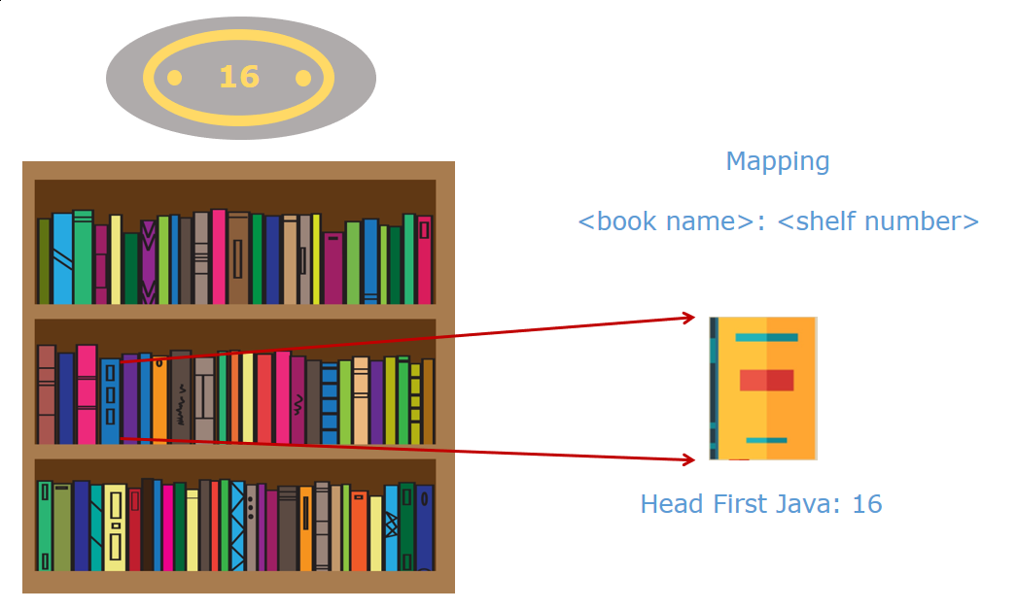

Here, there is a need to store two values for every element - Book name and shelf number.

The collections that you have seen till now allow us to store a single value for a given element but not two values.

In such cases, maps can be used which can be used to store key-value pairs.

A map represents a mapping between a key and a value. It is used to store data similar to a dictionary where lookup is performed based on a key and the respective value is returned.

In the case of Tree House Book Store, the key can be book name and the value can be shelf number as we would search for a book using the book name and try to find the shelf number of it.

In Java, Map is an interface defined as:

        public interface Map<K,V>

Here, K stands for the key type and V stands for the value type which can be any primitive type or a class.

Values in a map can be duplicates, but keys have to be unique. Having unique keys allows easier and faster access to the values.

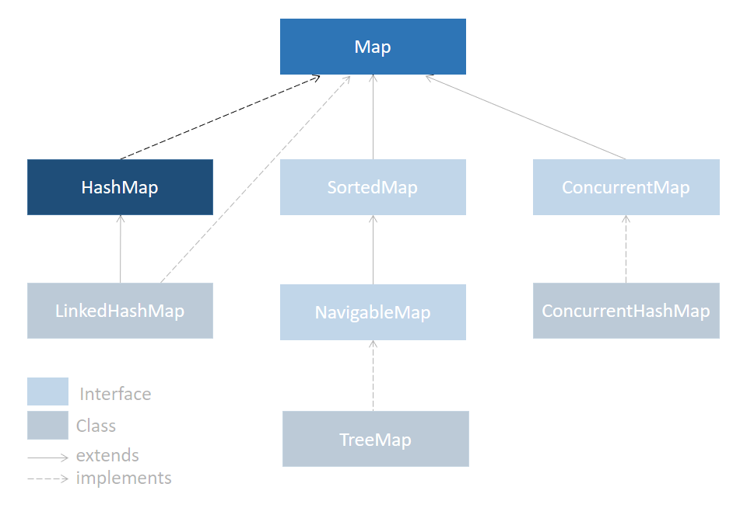

**HashMap**

The HashMap class implements the Map interface. We can create a HashMap in two ways:

1. HashMap<String, Integer> map = new HashMap<String, Integer>();
2. Map<Integer,String> map = new HashMap<Integer,String>();
3. map.put(1,"One");
4. map.put(5, "Five");
5. map.put(7, "Seven");
6. map.put(2, "two");

The above declarations represent that map will have a String as key and an Integer as a value. put() is used to add elements to the map. HashMap allows to have a null value and a null key. While retrieving elements HashMap does not guarantee order in which elements will be retrieved.

**LinkedHashMap**

LinkedHashMap is a child class of HashMap. It is a combination of Map and Linked List. Internally it uses doubly Linked List.It provides insertion order to the elements. Meaning that when elements are retrieved, they will be given back in the order in which they were inserted.

A LinkedHashMap object can be created as follows -

1. Map<Integer,String> lmap = new LinkedHashMap<Integer,String>();
2. lmap.put(1,"One");
3. lmap.put(5, "Five");
4. lmap.put(7, "Seven");
5. lmap.put(2, "two");

**TreeMap**

The entries in this map are sorted based on the natural ordering of keys. This class implements SortedMap interface. A **SortedMap**uses compareTo() method instead of equals() method for key comparison. The TreeMap class exclusively provides few methods such as firstKey(), lastKey(), etc.

A TreeMap object can be created as follows -

1. Map<Integer,String> tmap = new TreeMap<Integer,String>();
2. tmap.put(1,"One");
3. tmap.put(5, "Five");
4. tmap.put(7, "Seven");
5. tmap.put(2, "two");

Let us take a look at methods of HashMap class in detail.

Details of some of the methods of HashMap class are given below:

| ****HashMap Methods**** | |
| --- | --- |
| ****Method**** | ****Description**** |
| **V put(Object key, Object value)** | **Inserts the specified key-value pair in the map** |
| **V remove(Object key)** | **Deletes the element for the specified key** |
| **V get(Object key)** | **Returns the value for the specified key** |
| **boolean replace(K key, V oldValue, V newValue)** | **Replaces the old value with the new value for the specified key** |
| **void clear()** | **Removes all key-value pairs from the map** |
| **int size()** | **Returns the number of key-value pairs present in the map** |
| **boolean isEmpty()** | **Returns true if map is empty** |

Let us put some these methods to use-

To create and add elements to a HashMap, look at code below-

1. HashMap<String, Integer> books = new HashMap<String, Integer>();
3. *//Adding key-value pairs to the map*
4. books.put("Data Structures With Java", 50);
5. books.put("Operating System", 80);
6. books.put("Let Us C", 70);
7. books.put("Java Fundamentals", 40);

Checking the size of HashMap-

1. System.out.println(books.size());

To update a value in a HashMap -

1. *//Replacing key-value pair in the map*
2. books.replace("Operating System", 80, 100); *//Here value 80 gets replaced by 100*
3. System.out.println(books);

To retrieve a particular entry from the set -

1. System.out.println(books.get("Java Fundamentals");

There are multiple ways to remove elements from HashMap. Removal can be done based on key or combination of key-value pair.

1. *//Removing element based on key*
2. books.remove("Let Us C");
4. *//Below code will remove the book only if combination of given key and value is present*
5. books.remove("Let Us C", 50);

### ****Iterating over a HashMap-****

There are multiple ways of iterating over a HashMap. Below described techniques will work on LinkedHashMap and TreeMap as well.

### ****Using keySet()****

Map interface has a method keySet() which returns a set of keys in the Map. This can be used to iterator over Map as below-

1. Set<Integer> keys = books.keySet();
2. for(Integer key:keys) {
3. String value = map.get(key);
4. System.out.println(value);
5. }

### ****Using values()****

Map interface has a method values() which returns a collection of values in the Map. This can be used to iterator over Map as below-

1. Collection<String> cvalues = books.values();
2. for(String temp:cvalues) {
3. System.out.println(temp);
4. }

### ****Using entrySet()****

Map interface does not have iterator() method defined in it, hence we cannot use iterator() directly on Map. There is a helper interface Map.Entry<K,V> whose objects represent a Map's entry that is a key-value pair. These are available only during the iteration of a Map. There is a method in Map interface entrySet() which returns a set Map.Entry. This set represents all entries (elements) in a Map. We can use iterator() method on this set to iterate over HashMap.

1. *//Getting set of entries using entrySet()*
2. Set<Entry<Integer,String>> valueset = books.entrySet();
4. *//iterating over set*
5. for(Entry<Integer,String> obj:valueset) {
6. System.out.println("Key-"+obj.getKey()+" : Value-"+obj.getValue());
7. }

You can read more about HashMap by clicking [HashMap class](https://docs.oracle.com/en/java/javase/11/docs/api/java.base/java/util/HashMap.html).

Collections framework provides developers with a way to store, manipulate, and access related data in Java applications. It provides developers with means to manipulate data like sorting, searching, and insertion. And just like any other concept, the usage of collections also come with their own best practices and rules, which will be discussed in this module.

Here are a few best practices to be followed while using Collections.

* Choose the right collection
* The **interface type** should be used as a reference type
* **Generics** and **diamond<>**operator should be used
* Iterating using a **for-each** loop or **forEach** function
* Use of **isEmpty()** over **size()**method
* Implement **Comparable** interface fro comparing objects
* Overriding **equals()** and **hashcode()** methods

The above best practices are followed while implementing Collection are discussed further in detail.

An e-commerce application development team had a requirement to store and manipulate a large collection of data. This included returning a list of products based on their category, price, and, other filters to sort in ascending/descending order. Since the team had been following the best practices in their application, they decided to choose the best possible Collection which will meet all their requirements of processing large data in the most efficient way to improve the overall performance of the application. To do this they listed down all the requirements of their application and ruled out all the Collections that did not meet the requirement and selected the one that gave the best performance for their requirement.

Assume that a **Product**class exists as shown below.

1. class Product{
2. private Integer prodId;
3. private String prodName;
4. private String category;
5. private Float prodPrice;
6. public Product(Integer prodId, String prodName, String category, Float prodPrice){
7. *//code to set appropriate data to the instance varibles*
8. }
9. *//getters and setters*
10. }

Here is a list of requirements.

**Requirements:**

* Should store a large amount of data (Product information).
* Should not store duplicate data
* Should store the **Products** in the ascending order of the *prodId*or the *prodPrice*.

**Solution:**

* Based on the first requirement, the team selects **List**, **Map,** and **Set.**
* Since only **Set** and **Map**satisfied the second requirement,theList was removed.
* Since the **Map** requires data in key-value pairs it does not best suit our requirement. Hence it was removed.
* The **Products**inside the collection had to be sorted, hence the developers had only one option left i.e., **TreeSet**since it removes duplicates and stores elements in ascending or descending order based on a selected attribute(s).

**Similarly, as a good practice, any developer can go through this simple process and choose the right Collection before implementing the logic.**

The team of developers decided to use **TreeSet**for their requirements. They have implemented the actual logic to persist and process the Product details. Based on the requirement set of products are added to the TreeSet object which is declared as mentioned below.

1. *//TreeSet class is used as a reference type which is considered to be bad practice*
2. TreeSet productCollection = new TreeSet();
3. *//code to add Products to productCollection TressSet*

Technically there is nothing wrong with the above logic if the TreeSet is used as a reference type. But assume that after some time the list of requirements changes and the selected TreeSet object is no longer suited to match those new requirements. This means the TreeSet has to be replaced by another suitable Set throughout the application. To make this code to adapt any new changes it is a good practice to always use the **Interface** types of the collection as a reference type as shown below.

1. *//Considering interface reference type is a good practice*
2. Set productCollection = new TreeSet(); *//TreeSet object with Set reference type*
3. *//code to add Products to productCollection*

To perform an insert or delete operations the developer has to change only the implementation while the rest of the code can remain the same. The developer can use the LinkedHashSet object to store and access the data easier.

Since the reference of *productCollection*is Set interface, the developer has to change only the object type.

1. *//Good practice to use an interface reference type for any object creation*
2. Set productCollection = new LinkedHashSet(); *//LinkedHashSet object which satisfies new requirement*
3. *//code to add Products to productCollection*

**Hence, it is always a best practice to declare a reference variable with its Interface type instead of its own class type.**

Consider the code written by the developer to add products to the **productCollection**object. Assume that the **Product**classexists with *prodId*, *prodName*, *category*, *prodPrice*attributes.

1. *//Bad practice to create an object without generics*
2. Set productCollection = new TreeSet(); *//TreeSet object initialized*
3. *//Assume the Product class has implemented the Comparable interface*
4. productCollection.add(new Product(101,"Shirt","Clothing",1000.0f));
5. productCollection.add(new Product(102,"OneMinus 10","Electronics",100000.0f));
6. productCollection.add(new Product(103,"Shirt","Clothing",600.0f));
7. productCollection.add(101); *// Integer gets added to the productCollection*
8. productCollection.add("Some Random String"); *// String gets added to the productCollection*

Since there is no restriction on what type of data can be stored in the **productCollection** in the above code, any random data type can be stored which might lead to unchecked exceptions in the application during execution. To avoid this the team decided to use Generics to restrict the **productCollection**set to only contain **Product** objects and throw checked exceptions if other data types are being added as shown below.

1. *//Good practice to declare objects with generics*
2. Set<Product> productCollection = new TreeSet<Product>(); *//TreeSet object initialized which can only contain Product object*
3. *//or*
4. Set<Product> productCollection = new TreeSet<>(); *//in the latest versions of java this type of initialization is also supported*
5. *//Assume the Product class has implemented the Comparable interface*
6. productCollection.add(new Product(101,"Shirt","Clothing",1000.0f));
7. productCollection.add(new Product(102,"OneMinus 10","Electronics",100000.0f));
8. productCollection.add(new Product(103,"Shirt","Clothing",600.0f));
9. *//Compilation errors will be thrown for the below lines*
10. productCollection.add(101); *// Integer gets added to the productCollection*
11. productCollection.add("Some Random String"); *// String gets added to the productCollection*

**Generics are necessary to be used while declaring objects to avoid runtime exceptions as generics do compile type checking for specific datatypes only to be added.**

One of the features of this e-commerce application was that the end-users can filter the available products based on the product *category*. To implement this the developers have a lot of options to iterate through the collection and filter data, one of them is a traditional for-loop as shown below.

1. *//Assuming productCollection is populated with set of products*
2. for(int i = 0; i<productCollection.size() ; i++){
3. *//code to filter the set*
4. }

It is recommended to use the for-each loop since it is more readable compared to the traditional for-loop.

1. for( Product product : productCollection ){
2. *//Code to filter list based on category*
3. }

Collection interface also provides developers with a **forEach()** method which uses a lambda expression (will be discussed later). It is more compact and powerful compared to the traditional for-loop.

1. productCollection.forEach(product->{
2. *//code to filter and process data*
3. })

One of the common features of e-commerce is to overlook available products. For this, the developer writes code to display all the product details using a for-each loop. As they had followed the best practices throughout the application, they need to check if the Collection (*productCollection*) is empty or not before iteration to avoid errors.

The most popular way to check this is to use the size() method. But since there is a utility method isEmpty() is provided by the Collection interface, it is recommended to use isEmpty() over the size() as shown below.

1. Set<Product> productCollection = new TreeSet<>();
2. *//code to process data*
3. if(productCollection.isEmpty()){
4. *//code goes here*
5. }

Performance-wise there is a marginal difference between the two methods, it all comes down to the readability of the code and it is also better utilization of the code. If the developer uses size() method it might have to do two operations i.e., calling size() method and checking whether Collection size is 0, then it executes conditional statements.

In a scenario where a method should return Collection when no records/data is found, it is recommended that the method supposed to return an empty **Collection**rather than returning null.

One of the requirements of the collection was to store the elements in the sorted order based on the *prodId*. The developers decided to use the TreeSet collection which will obtain unique objects and sort all elements added to the collection. TreeSet internally uses the **compareTo()** method to compare any two elements for unique and sorted elements. If any user-defined objects are added to TreeSet compareTo() needs to be overridden for comparing objects to obtain unique objects and in sorted order. So the developers decided to implement the **Comparable** interface in the Product class as shown below.

1. class Product implements Comparable<Product>{ *//Comparable interface has been implemented*
2. *//Instance variables declared as prodId, prodName, category, prodPrice*
3. *//Parameterized constructors are added to assign instance variables*
4. *//Getters and setters*
5. @Override
6. public int compareTo(Product o) {
7. return this.prodId.compareTo(o.prodId); *//Products will be compared on prodId*
8. }
9. }

Here all the products will be compared by their prodId values and sorted accordingly, to remove any duplicates, the compareTo() method is returning 0 if the ***prodId*** of the two objects being compared are equal.

Note: TreeSet uses compareTo() method to sort and remove duplicates.

**Hence it is always good practice to override the compareTo() method in user-defined classes whenever class needs to be compared and sorted.**

A new requirement has come up such that the collection should not contain unique products. Since the *productCollection* contains user-defined objects the developers decided to override the **equals()** and **hashCode()** methods in the Product class so as to uniquely identify the *prodId*that can be stored in the collection. Assume that **Product**class exists as below and **HashSet** object is used for adding products.

1. class Product{
2. *//Instance variables are declared as prodId, prodName, category, prodPrice*
3. *//Constructors are defined to assign instance variables.*
4. *//Getters and setters*
5. @Override
6. public int hashCode() {
7. final int prime = 31;
8. int result = 1;
9. result = prime * result + ((prodId == null) ? 0 : prodId.hashCode());
10. return result;
11. }
12. @Override
13. public boolean equals(Object obj) {
14. if (this == obj)
15. return true;
16. if (obj == null)
17. return false;
18. if (getClass() != obj.getClass())
19. return false;
20. Product other = (Product) obj;
21. if (prodId == null) {
22. if (other.prodId != null)
23. return false;
24. } else if (!prodId.equals(other.prodId))
25. return false;
26. return true;
27. }
28. }

The **equals()** method has been overridden to return true only if the ***prodId***is the same and **hashCode()** will return a unique integer based on the ***prodId***.

This ensures that the *productCollection* will not contain any duplicate elements.

1. Set<Product> productCollection = new HashSet<>();
2. *//equals() and hashCode() methods are used to compare objects while adding elements to set*
3. productCollection.add(new Product(101,"Shirt","Clothing",1000.0F));
4. productCollection.add(new Product(102,"OneMinus 10","Electronics",100000.0F));
5. productCollection.add(new Product(101,"Shirt","Clothing",600.0F)); *//duplicate element*

The duplicate element with the ***prodId***as **101**will not be added for the second time.

**Therefore, if any user-defined classes are used in the Collections and if the elements have to be compared/checked for equality it is always a good practice to override the *equals(), hashCode(),*or*compareTo()* methods based on the Collection used.**

Consider the following array containing the name of employees who are working on different projects:

{Ajay, Sachin, Kamal, Swati, Ajay, Rahul, Amit}

Assuming that an employee can work on more than one project and all employees have different names, write a logic to:

* Print the name of employees along with the number of projects in which he is working
  + (Hint : Given Map <K,V> where K is the name of employee and V is the number of projects in which he is working)
* Print the names of employees who are working on the maximum number of projects

Note: You can add some sample data for Project and Employees.

**Sample Output:**

Employee with number of projects associated  
Rahul-1  
Amit-1  
Swati-1  
Kamal-1  
Ajay-2  
Sachin-1

Employee with maximum number of projects: Ajay

In a HashMap object we can add a user-defined object as a Key. In order to do this, one condition needs to be maintained. That is contract of equals() and hashCode() method must be upheld.

**Contract states that**

-if two  objects are considered to be equal then their hashCode() should also be equal

-if two objects are considered not to be equal then their hashCode() may or may not be equal

This can be done by overriding equals() and hashCode() methods accordingly.

Below code represents a Map of trainees with their batch names. Here Trainee object acts as a key and batch name acts as value. equals() and hashCode() methods have been overridden in the Trainee class.

**To Do:**

**Step 1:** Run the code and observe output

**Step 2:** Print all the keys in the Map

**Step 3:** Print all the trainee ids present in the keys

**Step 4:**Print all the entries of the Map

**Step 5:** Add the entries in below String to the Map

String traineeDetails = “105,Lily:Jan20-Lc2+106,Peter:Feb-Lc2+107,Jerry:Mar-LC1”.

Note: Check the project using SonarLint to maintain the coding standards. Ignore the violations which occur due to "System.out" statements.

InfyAcademy is an online academy that invites candidates to participate in various events, and also provides grades for each candidate based on his/her performance. They need your help in two modules,

* Adding candidates
* Getting candidate reports

| ****Artifacts:**** | |
| --- | --- |
| ****File Name**** | ****Status**** |
| **com.infy.dao.CandidateDAO.java** | **Implemented** |
| **com.infy.dao.CandidateDAOImpl.java** |
| **com.infy.model.Candidate.java** |
| **com.infy.model.CandidateReport.java** |
| **com.infy.service.CandidateService.java** |
| **com.infy.userinterface.CandidateTester.java** |
| **com.infy.exception.InfyAcademyException.java** |
| **com.infy.service.CandidateServiceImpl.java** | **To be modified** |
| **com.infy.validator.Validator.java** |
| **com.infy.test.CandidateServiceTest.java** | **To be ignored for now** |

Click on [InfyAcademyDay3ToTrainee](https://academy.onwingspan.com/common-content-store/Shared/Shared/Public/lex_auth_012971870140620800123_shared/web-hosted/assets/InfyAcademyDay3ToTrainee1641472564670.zip) to downloadto downloadthe starter code for this assignment. Refer **Appendix->Import Maven project in Eclipse**at the end of the course for importing the project and updating to Maven**.**

**Exceptions:**

**InfyAcademyException** - (Implemented)

This is a user-defined Exception used to throw an exception in this application.

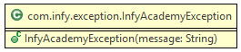

**InfyAcademyException**(String message)

This is a constructor for the InfyAcademyException class with a message as a parameter.

**Validator:**

This class validates the input provided by the user.

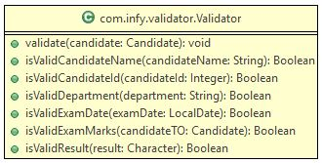

Out of the 7 methods present, 6 have been implemented. You will have to implement one method based on the description given below.

**validate(Candidate candidate):**

This method should call the validation methods for individual inputs, and if any method returns false, then throw an InfyAcademyException with the relevant String message as shown in the table below,

| ****Validation**** | |
| --- | --- |
| ****Input**** | ****Exception message**** |
| **candidateId** | **The entered candidate ID is invalid.** |
| **candidateName** | **The entered candidate name is invalid.** |
| **mark1, mark2, mark3** | **The entered exam marks are invalid.** |
| **result** | **The entered result is invalid.** |
| **department** | **The entered Department name is invalid.** |
| **examDate** | **The entered Exam Date is invalid.** |

**CandidateServiceImpl:**

This class takes care of the business logic of the whole application.

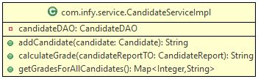

Out of the three methods of the class, one has been implemented for you. You will have to implement the other two based on the description given below.

**addCandidate(Candidate candidate):**

This method receives a Candidate object to be added to the database. It will validate the inputs, and once validated, will send it to the database to be added.

* Invoke the **validate()** method of the **Validator**class by passing the received Candidate object as the parameter to validate the input.
* If the input details are validated(i.e., if the **validate()** method does not throw an exception), check the **result**attribute of the Candidate object.
* The **result**attribute should be **F** if any one of the **mark**attributes of the Candidate object is less than 50.
* If even one **mark**attribute is less than 50, and the result is **P**, then throw an Exception with the message, **Result should be 'F' (Fail) if student scores less than 50 in any one subject**
* Else, invoke the **addCandidate()** method of the **CandidateDAOImpl**bypassing the Candidate object as the parameter, which will return a String value.
* Return the String value obtained in the previous step.

**getGradesForAllCandidates():**

This method retrieves all the Candidate reports from the database and returns a Map of the candidate ID and respective grade allocated to the candidate.

* Invoke the **getAllCandidates()** method from the **CandidateDAOImpl**class which will return an object **List<CandidateReport>**.
* Iterate over the List received in the previous step, and create an object of **TreeMap<Integer, String>** with the key as the **candidateId**of each candidate and the value as the **grade**of each candidate.
* To obtain the grade of each candidate, invoke the **calculateGrade()**method of the **CandidateServiceImpl**class by passing each candidate object present in the List as the input. This method will return you the grade for the candidate object passed.
* Once the **candidateId**and the **grade**of all the candidates in the **List<CandidateReport>** is added to the **TreeMap**, return the populated **TreeMap**.

**Sample Input and Output:**

**Add Candidate**

| ****Input Data**** | |
| --- | --- |
| ****Attribute**** | ****Value**** |
| **candidateId** | **12346** |
| **candidateName** | **Sam** |
| **mark1** | **51** |
| **mark2** | **56** |
| **mark3** | **78** |
| **result** | **P** |
| **department** | **ECE** |
| **examDate** | **29th May, 2014** |

* **Output**: Candidate details are successfully added.

**Get Candidate Result**

**Output**:

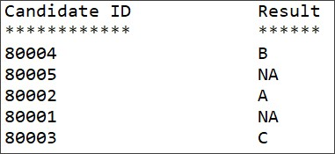

**Note**: Check the project using SonarLint to maintain the coding standards. Ignore the violations which occur due to "System.out" statements.

Consider a case where the date and time needs to be represented for different users of the application who are globally located. They need to get the date and time, login time, meeting scheduled time etc., based on their local date and time.

ZonedDateTime class in Java helps in meeting the above requirement.

**ZonedDateTime** is a class that represents a date and time with time zone. E.g. 2020-06-11T19:22:59.235+05:30[Asia/Calcutta] represent the date and time in India.

ZonedDateTime is an immutable class present in java.time package. This class can represent all date and time fields to a precision of nanoseconds.  
It provide various methods like now(), of(), withZoneSameInstant(), toLocalTime() etc. for creating a ZonedDateTime or for modifying it.

Below given code demonstrates some of the methods of ZonedDateTime class.